How a Punjab entrepreneur built a Rs 2.1 crore grafted vegetables business
The overwhelming response encouraged Bhaskar to establish Aruj Nursery, North India's first specialised grafted vegetable nursery, at Sehjowal village in Rupnagar's Nangal tehsil in 2022.
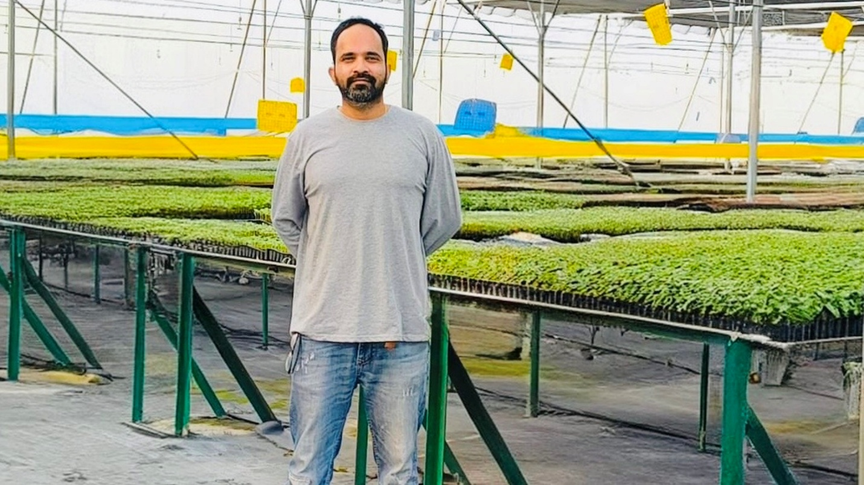
Before Rajeev Bhaskar sold his first grafted vegetable seedling, the 34-year-old horticulture graduate gave away nearly one lakh of them without charging a rupee across Punjab, Haryana and Himachal Pradesh in 2021. There were no customers, no revenue and no guarantee the experiment would succeed. He was not trying to sell, but to convince sceptical farmers that a technology unfamiliar to them could transform vegetable cultivation.
“Nobody would have believed in grafted vegetables simply because someone claimed they worked,” Bhaskar says. “Farmers had to see results in their own fields, and not a single farmer complained about the performance.”
Grafted seedlings, produced by joining the rootstock of a strong, disease-resistant plant with the scion of a high-yielding variety, were sourced from Raipur, Chhattisgarh, where the technology was already established. The exercise was never meant to generate revenue but to build trust.
The gamble paid off. Farmers reported healthier, pest-free crops, stronger plants and almost no incidence of destructive soil-borne diseases such as bacterial wilt. Word spread quickly, and those who had tried the free seedlings returned with larger orders.
“The rootstock provides disease resistance and tolerance to environmental stress, while the scion ensures superior yield and fruit quality,” Bhaskar explains.
The overwhelming response encouraged Bhaskar to establish Aruj Nursery, North India’s first specialised grafted vegetable nursery, at Sehjowal village in Rupnagar’s Nangal tehsil in 2022. He partnered with healthcare entrepreneur Dr BK Sharma and his son Ahsas Sharma, a technology professional.
Bhaskar manages production and technical operations, while the Sharmas provided land and investment. Together they invested nearly Rs 1.30 crore in two naturally ventilated polyhouses covering about 3,000 square metres each and other facilities. Though eligible for a subsidy on the polyhouses, they are yet to receive it. Even so, they expect to recover their investment this year and begin making profits.
The first year proved difficult. The nursery produced only 50,000 grafted seedlings in 2022 and ended with a deficit of nearly Rs 18 lakh, because of heavy infrastructure costs and limited farmer awareness.
Four years later, the picture changed dramatically. This year, the nursery has produced around 12 lakh grafted vegetable seedlings and expects a turnover of more than Rs 2.10 crore in 2026, up from Rs 1.60 crore in 2025, making it one of the fastest-growing specialised grafted vegetable nurseries in the region.
“The nursery was established to make grafting technology accessible to vegetable growers across North India by providing practical technical guidance to farmers,” Dr Sharma says.
Bhaskar’s journey began after completing his BSc in Horticulture from GB Pant University in 2013. He joined a multinational vegetable seed company in Chhattisgarh, where he worked until 2017 and received advanced training in vegetable grafting through programmes and visits to Kasetsart University in Thailand. He later conducted successful demonstrations of grafted vegetables in Punjab. Between 2018 and 2021, he worked in farming and horticulture consultancy, laying the foundation for the nursery.
“Farmers in Chhattisgarh have been using this technology since around 2008. I realised Punjab was still largely unaware of its potential,” he says.
According to Bhaskar, vegetable growers continue to battle soil-borne diseases, particularly bacterial wilt, which severely affects vegetables. Once infected, fields often become unsuitable for growing the same crop, and there is virtually no effective chemical treatment. “Grafting offers the most practical solution,” he says. “Instead of growing vegetables on their own roots, we combine disease-resistant rootstocks with high-yielding commercial varieties. The roots resist disease while the upper portion produces better-quality fruits and higher yields.”
The technology also provides greater tolerance to waterlogging.
The nursery has the capacity to produce nearly 32 lakh grafted vegetable seedlings and 64 lakh conventional seedlings annually. It specialises in grafted brinjal, tomato, coloured capsicum, and bitter gourd, as well as conventional vegetable seedlings and grafted fruit plants. Production follows seasonal cycles, with brinjal remaining in the nursery for about 90 days, tomato and coloured capsicum for around 70 days, and bitter gourd for about a month.
The biggest challenge, Bhaskar admits, is convincing farmers to pay more. A conventional seedling costs about Rs 2, while a grafted one costs nearly Rs 12.
However, he says the economics strongly favour grafted plants. A conventional brinjal plant produces about 10 kg during its productive life, while a grafted plant generally yields at least 20 kg and often up to 30 kg.
An acre accommodates 2,200-3,000 brinjal plants. Conventional seedlings yield 22,000-30,000 kg per acre, while grafted plants produce 44,000-60,000 kg and can reach 66,000-90,000 kg under good management. At an average wholesale price of Rs 10 per kg, farmers can earn Rs 6-9 lakh per acre from grafted plants compared with Rs 2.2-3 lakh from conventional crops, despite spending only about Rs 27,000 on grafted planting material.
Now the nursery receives orders from across several states from 100s of farmers.
Spread over about three acres, the nursery provides year-round employment to 22 permanent workers and another 15-20 seasonal workers during peak operations.
As vegetable cultivation faces increasing pressure from disease, climate variability and shrinking profit margins, Bhaskar believes grafting will become a necessity rather than a niche technology. “If farmers trust the technology, the business follows on its own,” he says.

