NETS OVER 50% PROFIT: Small farmer from Tarn Taran builds ₹1-Cr flower farming model
Twenty-five years ago, when Jarnail Singh, now 45, a small farmer, ventured — as an experiment — into floriculture on just his two kanals of land he had, he had not imagined that in years to come, through his enterprise, he would be able to turn it into a flourishing business with Rs 1 crore
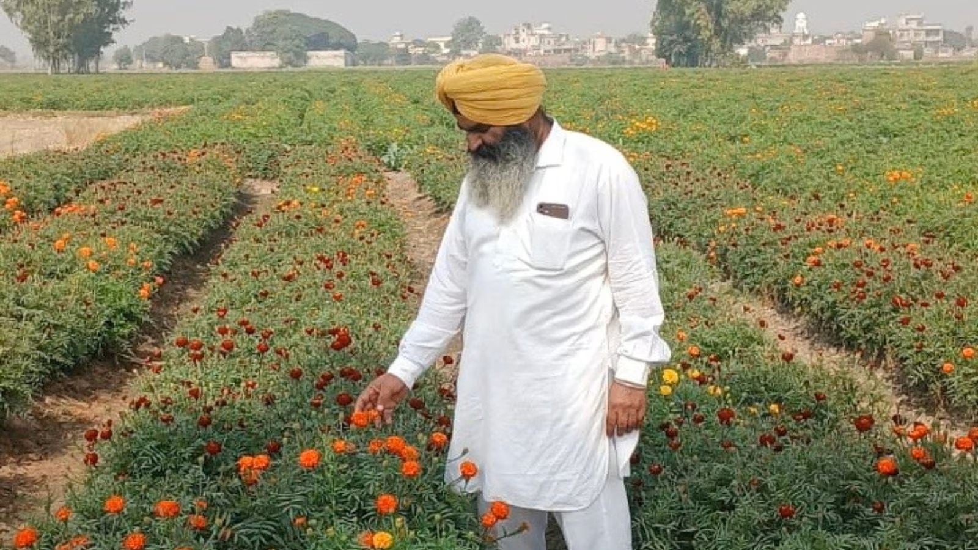
Twenty-five years ago, when Jarnail Singh, now 45, a small farmer, ventured — as an experiment — into floriculture on just his two kanals of land he had, he had not imagined that in years to come, through his enterprise, he would be able to turn it into a flourishing business with Rs 1 crore per annum turnout, with his profit margin exceeding 50 per cent.
Life was tough when Jarnail first thought of taking a leap towards floriculture, leaving traditional wheat and paddy cultivation behind, but over the past 25 years, this farmer from Jagatpura village under Ghadiwindblock of Tarn Taran district expanded his flower cultivation to nearly 25 acres — leasing 20 acres — and turned it into a business generating over Rs 1 crore annually — and what went into was relentless hard work and determination to succeed with a vision of a bright future.
A matriculate by education, Singh considers his father his inspiration. The father would accompany him to the Punjab Agricultural University’s (PAU) Kisan Melas (Farmers’ Fair) in Ludhiana and had a keen interest in vegetable cultivation, especially onion.
“After my schooling, as a teenager, I started with marigolds on just two kanals using seeds sourced from PAU. Over time, I realised the potential of flowers compared to traditional crops like wheat and paddy,” Singh said.
Today, Singh cultivates flowers on around 25 acres for almost eight months. Nearly 20 acres he has taken on lease for Rs 65,000 to Rs 70,000 per acre annually. Despite the high lease cost and labour-intensive cultivation, floriculture proved profitable over the years.
His main crops include varieties of marigold such as Jaffri or Jafri Gainda (marigold) in red, yellow and orange shades, along with seasonal cultivation of chrysanthemum (guldaudi) in white and yellow and Laddu gainda (during summer). He sources varieties, such as Laddu gainda, from Kolkata while he prepares the nursery of Jaffri and Guldaudi.
Explaining the cropping cycle, Singh said Laddu gainda is sown around February and the first harvesting starts in April, which goes on till the beginning of July, while Jaffri marigold is planted in September and becomes ready for first harvesting between October and November, coinciding with peak festive demand, and which goes on till January, and then the same fields are used for growing Laddu gainda. “Timing is crucial as prices are highest during festivals like Dussehra and Diwali,” he added.
On average, Singh harvests around 80 to 100 quintals of Jaffri marigold per acre and around 60 quintals of Laddu gainda per acre.
“Once the picking of flowers starts, we pluck them twice or thrice in a week for around 3-4 months before going to the next crop,” he said.
Prices, however, vary depending on season, averaging around Rs 25 per kg, but rising significantly during peak demand periods. On average, he sells around 3,800 to 4000 quintals of flowers with an average rate of Rs 2,500 per quintal.
Apart from floriculture, Singh also grows Basmati rice 1509 between July and September, which is a short-duration variety and matures in 90 to 95 days after transplantation of around one-month-old seedlings in the field.
“Flower cultivation is challenging during the rainy season, so I halt flower cultivation for around four months and cultivate Basmati on the same land to enhance income further. Apart from this, I also cultivate green onions and vegetables such as peas and French beans on a smaller scale when my fields are free after Basmari, as I plant Jaffri varieties not in one go, but after some gaps,” Singh said.
He produces around 500 quintals of Basmati and over a couple of 100 quintals of vegetables, making his enterprise worth over Rs 1 crore after paying around Rs 14 lakh rent for the leased land annually and input costs of flower, Basmati seeds and vegetables cultivation, but he manages to earn over a 50 per cent profit.
“My father had 7 acres, which was divided equally between my brother, who is serving in the Army, and me. With the income from flower cultivation, my brother and I purchased more 3 acres around 7 years ago. Now, we both have 5 acres each with us, as I am also cultivating the land of my brother.”
The farmer has also developed his own nursery system. “In less than one kannal (1/8th part of one acre) of nursery can provide planting material for the entire 25 acres,” he explained, adding that maintaining quality seedlings is key to higher productivity. He plants around 16,000 saplings per acre for Laddu gainda and about 8,500 for Jaffri.
Labour management is another major component of his operation. Singh employs around 25 workers for nearly eight months of the year, with five labourers around the year.
Despite his success, Singh admits that marketing remains a challenge at times, especially when prices fluctuate due to oversupply.
However, his model has inspired other farmers in the region. “Many farmers are now shifting to flower cultivation on a small scale in my village after seeing my fields,” he said, adding that his son Harmanpreet Singh, who is doing BCom, is a great help in marketing as well as helping him manage farm activities.
This year, Punjab Agricultural University has awarded him in the field of floriculture for growing not only the best quality flowers, but also for how a small farmer successfully diversified into flower cultivation by shunning paddy and wheat. Also, in 2025, he was awarded by PAU for growing the best quality green onions.
Dr TS Riar, scientist and Additional Director of Communication, PAU, said, “Singh actively participates in Kisan Mela and awareness programmes, sharing his experience with others. His journey from two kanals of flower cultivation to a large-scale commercial venture highlights the growing potential of crop diversification in Punjab, even by a small farmer, especially at a time when traditional farming is facing sustainability challenges.”

