How diversification, sustainability, & land-leasing helped a small farmer in building Rs 1-cr annual enterprise
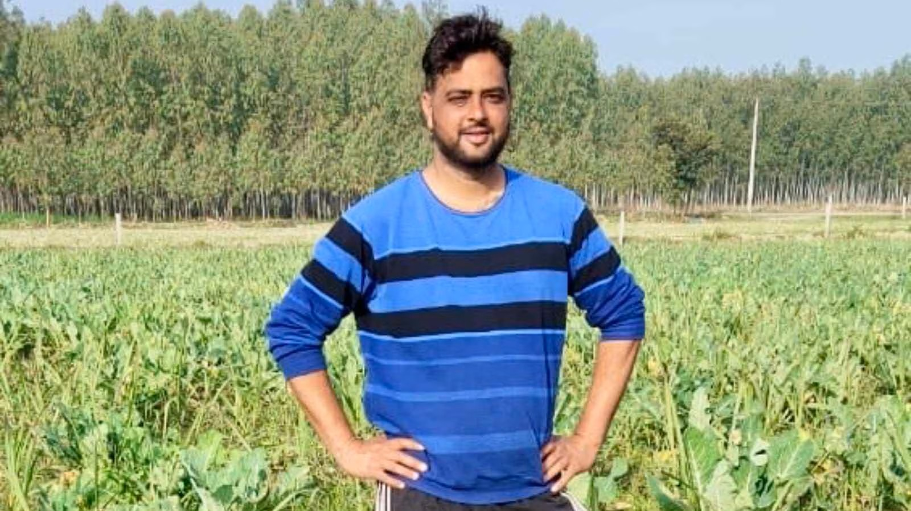
In the quiet lanes of Fatehpur village, located in the Bhunga block of Hoshiarpur district, lives a 40-year-old farmer who has turned his modest three-acre ancestral land into a thriving model of diversified and sustainable farming. Now, Manpreet Singh, manages an impressive 40 acres of farmland, 37 of which are leased, proving that success in agriculture is determined by vision and planning, not just the size of the land one owns.
Manpreet’s journey began in 2000 when he completed his 10+2 education. Motivated by his father, a retired Subedar Major from the Indian Army, who encouraged him to stay connected to the soil and build something meaningful, he began cultivating wheat, paddy, and maize on the family’s three-acre plot. He also leased an additional 10 acres to expand his operations then.
“Farming was never easy, but I wanted to prove that with hard work and planning, even a small farmer can grow big,” Manpreet says, standing proudly beside his fields of poplar trees.
Over the years, the farmer transformed his traditional farming methods into a diversified and integrated agricultural system. He gradually reduced his reliance on wheat and paddy, shifting towards sugarcane cultivation, animal husbandry and agroforestry. Rows of poplar and eucalyptus trees now stand as a testament to his long-term vision and commitment to sustainability.
Of his total 40 acres, 24 are dedicated to sugarcane cultivation, including four acres under organic farming. Manpreet practises intercropping, growing potatoes, wheat, and vegetables between sugarcane rows to maximise land productivity. Additionally, 12 acres of his land are under agroforestry, where he cultivates poplar and eucalyptus trees. The remaining area is used for other crops, including seasonal pulses and oilseeds. He also grows green manure to improve soil fertility and enhance crop yields.
In 2013, Manpreet ventured into pig farming with just ten pigs — eight females and two males. Today, his piggery has grown substantially, with 175 pigs, primarily females. He sells around 150 to 200 mature pigs worth Rs 30- 40 lakh each year, along with piglets. “A mature pig fetches ₹15,000 to ₹20,000, depending on the market,” he explains. “The expenditure on rearing each pig is around ₹8,000 to ₹9,000, but it’s a good parallel source of income that complements my crop farming.”
What truly sets Manpreet apart from other farmers is his focus on value addition. Apart from selling cane to sugar mills from his 20 acres out of 24 at MSP around Rs 400 per quintal, he processes his own jaggery and jaggery powder from organically grown sugarcane on his four acre land. “I sell part of my organic cane produce directly to local cane juice sellers at a premium rate of ₹1,500 per quintal, while the MSP of cane is just ₹400,” he says with pride. This innovative approach helps him to generate a revenue of worth around Rs 40 to 42 lakh from sugarcane cultivation and its processed products.
In 2021-2022, the 40-year-old expanded further by setting up a poultry unit with just one pair of desi hens. Today, he has around 150 hens in an open-cage system. These stress-free hens provide fresh eggs daily, and generate earnings of ₹1,000 to ₹2,500 per day by way of 50 to 100 eggs getting sold. The income from poultry adds another valuable stream to his self-sustaining farming model.
Although most of the land he leases has sandy soil, this has not deterred Manpreet from growing crops. In 2023, he introduced a rain gun irrigation system on six acres of his sugarcane fields, reducing water use by almost 70 per cent.
“This system not only saves water and reduces input costs, but it also offers promising returns of around ₹6 lakh per acre every four years, with an input cost of just ₹10,000.”
His agroforestry efforts further enhance soil quality and moisture conservation, contributing to long-term sustainability.
“After four years from 12 acres, I can sell the trees worth Rs 72 lakh. But I am developing a system under which I can sell trees from around 4-5 acres (worth Rs 24 to 30 lakh yearly) every year instead of selling all of them in just a single year and then wait for another four years to harvest them.”
As he points to his young poplar and eucalyptus plantations, Manpreet says that he plans to expand his agroforestry area to about 20 acres as “it has great future”.
Through his innovative and diversified approach, Manpreet has created a self-reliant, multi-income farm enterprise, which can generate annual revenue of ₹95 lakh to ₹1 crore, depending on market prices. After covering his expenses, including the ₹10 lakh rent for leased land and other operational costs, he enjoys a 40 per cent profit margin.
“I only own three acres of land, but I’ve created a system where I earn more than many corporate jobs,” says Manpreet, who has been recognised with the Parvasi Bharti Puraskar (NRI award) by Punjab Agricultural University (PAU) for his achievements in diversified farming.
“My father taught me discipline, and farming taught me patience,” reflects Manpreet. “Together, they built my life.”
Dr Satbir Singh Gosal, Vice-Chancellor of PAU, aptly sums up the farmer’s achievements: “From a three-acre beginning to managing 40 acres through strategic leasing, Manpreet has built a self-reliant, multi-income farm enterprise. His work is a shining example of the evolving face of Punjab’s agriculture, where traditional wisdom meets modern diversification. In a world where agricultural success often depends on scale and land ownership, Manpreet Singh’s story stands as proof that with vision, hard work, and innovation, a small farmer can achieve remarkable success”.

