From ‘dunki’ dreams to diversification driver: How a failed migration bid helped Punjab farmer rewrite the future
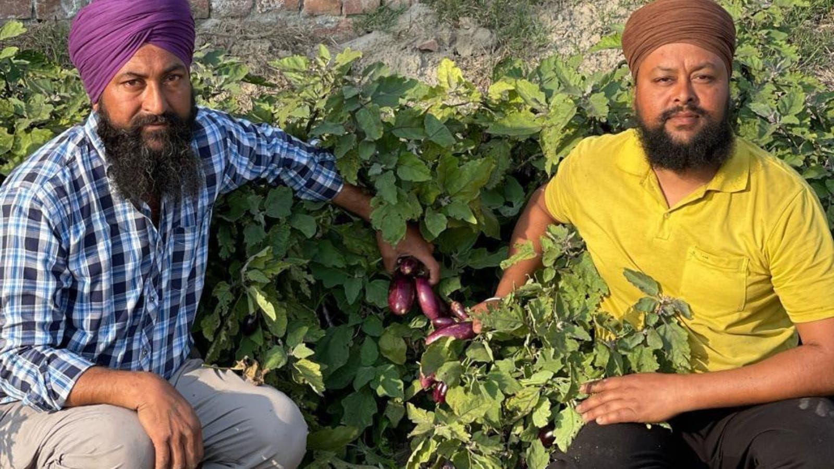
Chirmal Singh Sekhon restlessly up and down in the premises of Delhi’s Bangla Sahib gurdwara, checking his phone every few minutes waiting for a call. An agent had promised to send him to the United States via the dunki route — Delhi to Nicaragua, then Mexico, and finally entry into the US — all within seven days.
The cost: Rs 90 lakh, payable after landing, for his entire family. To realise the dream, Chirmal was ready to sell his ancestral land in Punjab. The phone call he was waiting for, however, never came.
That was in 2022. Three years later, standing on that same land in Daska village of Lehragagga in Sangrur district — now neatly divided into thriving vegetable patches — he calls his failed migration bid “the biggest blessing of my life.” That failed migration bid also it pushed him into agriculture, something he had avoided for nearly a decade despite belonging to a farming family.
Like thousands of other youth in Punjab’s hinterlands, Chirmal too believed that migration was the only path to prosperity. He proved himself wrong.
Now, he sells about a quintal of vegetables daily, earning Rs 2,500–3,000 or more per day depending on demand. He claims an annual income of nearly Rs 3 lakh per acre from vegetables — more than three times the combined earnings from wheat and paddy per acre.
“Had I not failed in going abroad, I would never have learned how profitable agriculture can be. Those who say farming is finished don’t understand it. My income is no less than the dollars that I would’ve made had I migrated,” he says, adding that the real change came when he shed hesitation and began selling produce directly, like a retailer.
Instead of selling through mandis and middlemen, he personally markets his vegetables in nearby villages. In wholesale mandis, vegetables often fetch Rs 5–20 per kg, while consumers buy the same produce at Rs 30–50 per kg from retailers. By selling directly, Chirmal earns Rs 25–40 per kg, while consumers get fresh produce at lower prices.
His vegetables are currently sold in three villages, including his own, with announcements made through gurdwaras to inform residents of fresh arrivals. Sales timings are adjusted seasonally—afternoons in winter and early mornings in summer.
As he expands vegetable cultivation, he plans to cover more villages. He believes the biggest barrier for farmers isn’t diversification, but social conditioning.
“Most farmers feel hesitant or even ashamed to sell their own produce. They prefer mandis, where traders decide the rates. Then they say, ‘fasal mandi ch gayi si…jo rate aaye, oh hi mil gaye’ (we got whatever rate was offered in mandi). But why should someone else decide the value of our hard work?”
Punjabis readily do all kinds of work abroad without hesitation, yet feel awkward selling vegetables in their own villages, he says.
“In mandis, even farmers become labourers, while traders earn from their produce,” he says. “Unless farmers break this mindset, diversification alone won’t bring profits.”
Chirmal’s journey away from farming began early. At 20, he left for Chandigarh in 2010, working as a driver, mall employee, and later as a taxi driver in Delhi. Influenced by an agent and a friend in the US, he applied for Canada and Europe, but both visas were rejected. The agent then pitched the dunki route, assuring air travel and payment only after arrival.
Chirmal and others waited at Bangla Sahib for a week, repeatedly told they would fly “today or tomorrow.” The flight never happened. Later, they were informed that the chartered plane used earlier had been detained in France. Disillusioned, Chirmal returned home.
Back in Punjab, his family urged him to do something productive. Almost reluctantly, he sowed pumpkin on just two kanals of land. In three months, after expenses, he earned Rs 1.17 lakh.
“That changed my thinking forever,” he says.
Encouraged, he expanded vegetable cultivation to 2.5 acres, nearly nine times the initial area, scaling up steadily over the last two years. His joint family of 15 owns around 10 acres. Wheat and paddy are still grown on seven acres.
The family now grows a wide range of seasonal and off-season vegetables — pumpkin, garlic, carrots, turnips, potatoes, peas and gourds — and plans to add turmeric and processing units like pickle-making. Chirmal aims to raise per-acre income to Rs 5–6 lakh.
Fields are divided strategically, with up to eight crops grown on one acre through careful timing. Nurseries are prepared in advance, plots reused immediately after harvest, and the same land is cultivated three times a year. The family employs about a dozen labourers for several months annually.
“All family members work in the fields — even the children,” Chirmal says. “They are learning agriculture hands-on.”
Now, he says he will go abroad only as a tourist — never to settle. Looking back, he regrets the years spent chasing foreign dreams, but without bitterness. “I learned that dignity, income and family can grow together,” he says, “if you trust your own soil.”

