From surplus milk to sold-out mornings: Hoshiarpur farmer’s tale of dairy empire
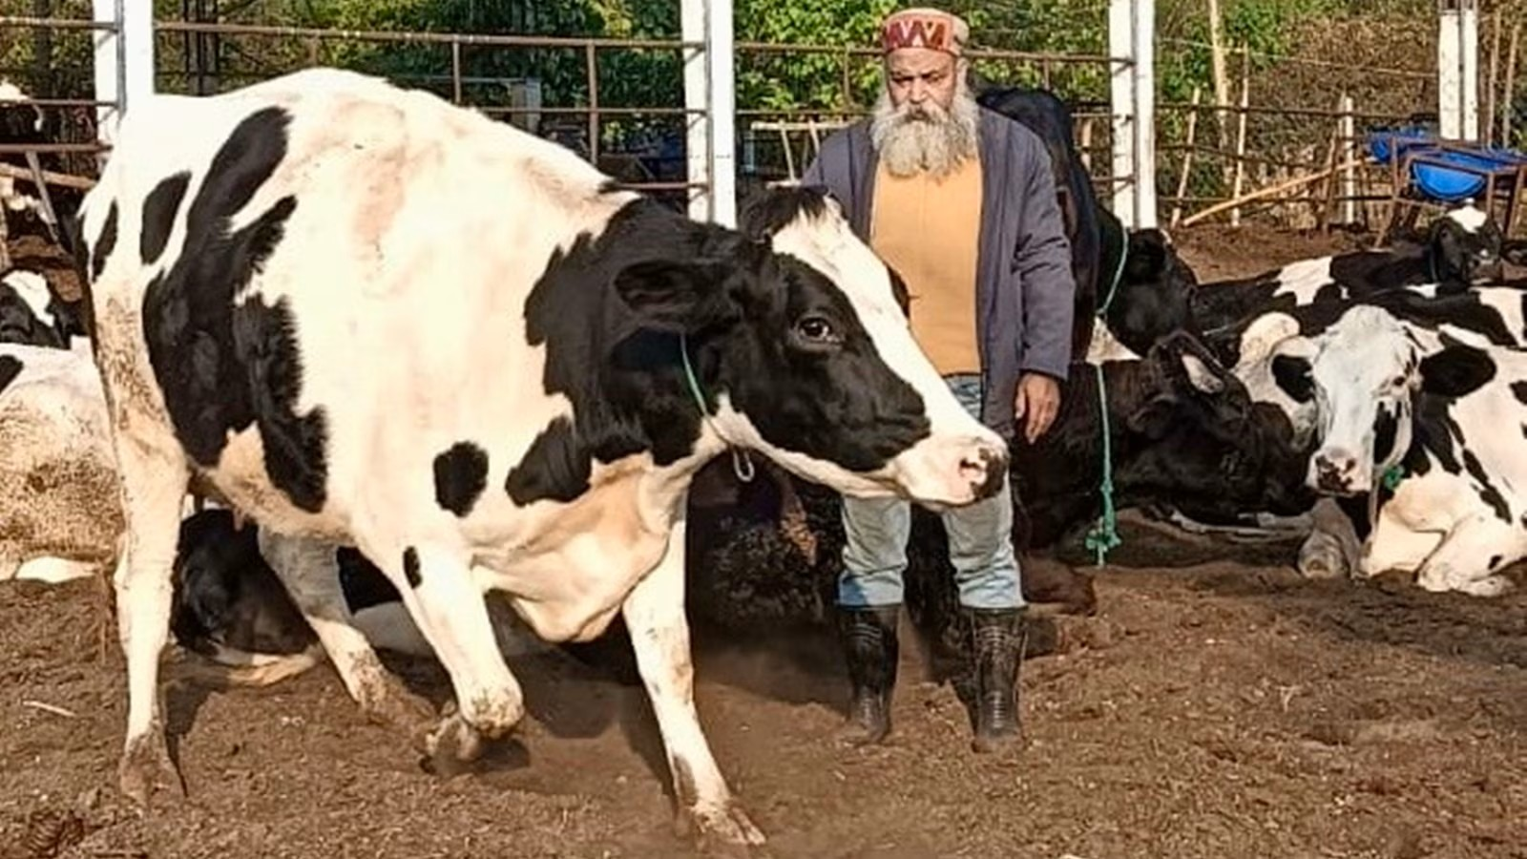
What began as subsistence farming to feed a family has today transformed into a successful agri-entrepreneurship model generating an annual revenue of over Rs 1 crore for a marginal family from Hoshiarpur’s Mehlanwali village.
Forced to leave his BSc studies in the final year due to family circumstances, Sanjeev Kumar Kahol took up farming in the early 1990s after the death of his father and brother. They used to run the family’s transport business.
For years, the 56-year-old Kahol grew vegetables and grains largely for household consumption on the two acres of land he owned. While struggling to make ends meet, he also sold small quantities of produce in the market.
A major shift came in 2015–16, when Kahol underwent a formal training in dairy farming and invested in 10 cows with a loan of Rs 16 lakh. Although Rs 8 lakh was promised as a subsidy under a government scheme, it never materialised.
In 2018, dairy farmers went on a nationwide strike demanding better milk prices.
With major suppliers stopping procurement for three days, Kahol was left with around 200 kg of unsold milk daily. In desperation, he offered free milk on social media. Instead, local shopkeepers approached him and requested direct supply.
People willingly paid Rs 40–45 per litre — more than double the corporate procurement price. Initially, he supplied milk to Nestlé at Rs 20 per kg, but the margins were very low.
Kahol says, “Encouraged by the response, I decided in July (2018) to market my milk directly to consumers. On the first day, we sold to 10 families. The next day, those families brought more customers. Within a few days, all our milk was being sold directly to people, and I stopped supplying to companies altogether.” He managed to repay his loan, including the subsidy portion, within a couple of years.
The COVID-19 lockdown in 2020 further strengthened this shift. With supply chains disrupted, the family began processing milk into paneer, curd, lassi and butter. The overwhelming response marked the beginning of their self-marketing journey for processed dairy products.
Today, the family — originally from Mawa Kaholan village in Una district of Himachal Pradesh — runs the enterprise as a close-knit team. His son, Kartik, manages dairy operations; his wife, Reeta Sharma, oversees processing; while Kahol handles marketing.
Under the brand “Farm Fresh Safe Food”, they sell nearly 20 value-added products prepared from their own farm produce.
Every morning, Kahol transports around 2.5 quintals of milk and nearly 50 kg of processed dairy products on an e-rickshaw to a small plot in Hoshiarpur city.
Sales begin at 7.30 am and are usually completed within 30 minutes. Orders for the products are coordinated through a WhatsApp group of nearly 100 regular customers. In the evenings, the family also provides home delivery in selected areas.
The dairy unit has now expanded from 10 cows to 30, with 15–16 cows producing milk at any given time.
Milk is sold at Rs 70 per kg, curd at Rs 120 per kg, paneer at Rs 600 per kg, lassi at Rs 60 per kg and butter at Rs 1,000 per kg.
Overall, nearly three quintals of milk and milk products worth Rs 27,000–30,000 are sold daily, translating into Rs 8–9 lakh per month, with an estimated profit margin of around 30 per cent.
Beyond dairy, Kahol has diversified into vegetable cultivation and fruit processing. His farm has 42 fruit trees, including mango, amla, lemon, apple, anjeer, ber, guava, galgal (Hill Lemon), sindoor (Lipstick Tree) and other local varieties. These are processed into pickles, murabba, candies and powders.
Seasonal vegetables fetch an additional Rs 2,000–3,000 daily during peak season. He also grows turmeric on around two kanals and sells it raw or as pickles.
Looking ahead, Kahol plans to convert his entire two acres into natural farming in February, without ploughing or using farm implements. Using mulching and minimal intervention, he aims to showcase a sustainable farming model. “In natural farming, there is no need to plough fields. The soil becomes softer naturally, and crops can be sown using mulch from leaves and wild vegetation.”
From barely earning enough for basic needs to generating more than Rs 1 crore annually, Kahol’s journey stands as a remarkable example of innovation and resilience. Recognising his efforts, Punjab Agricultural University (PAU) honoured him this year with the Sardar Surjit Singh Dhillon Award for Self-Cultivating Small Farmers under its initiative ‘Apni Jins To Utpad Banao Te Munafa Kamao’ (Process your own produce and earn profits).
“With continuous training, technical knowledge and strong family teamwork, marginal farmer Sanjeev Kumar Kahol has not only transformed his own life but has also set an inspiring example for marginal farmers across Punjab,” said PAU Vice-Chancellor Dr Satbir Singh Gosal.
Kahol has built a loyal base of more than 100 families who buy from him daily by combining innovation, value addition and direct marketing.

