From Rs 4L to Rs 27L monthly sales in just 9 months: How two marginal farmer brothers built a thriving dairy empire
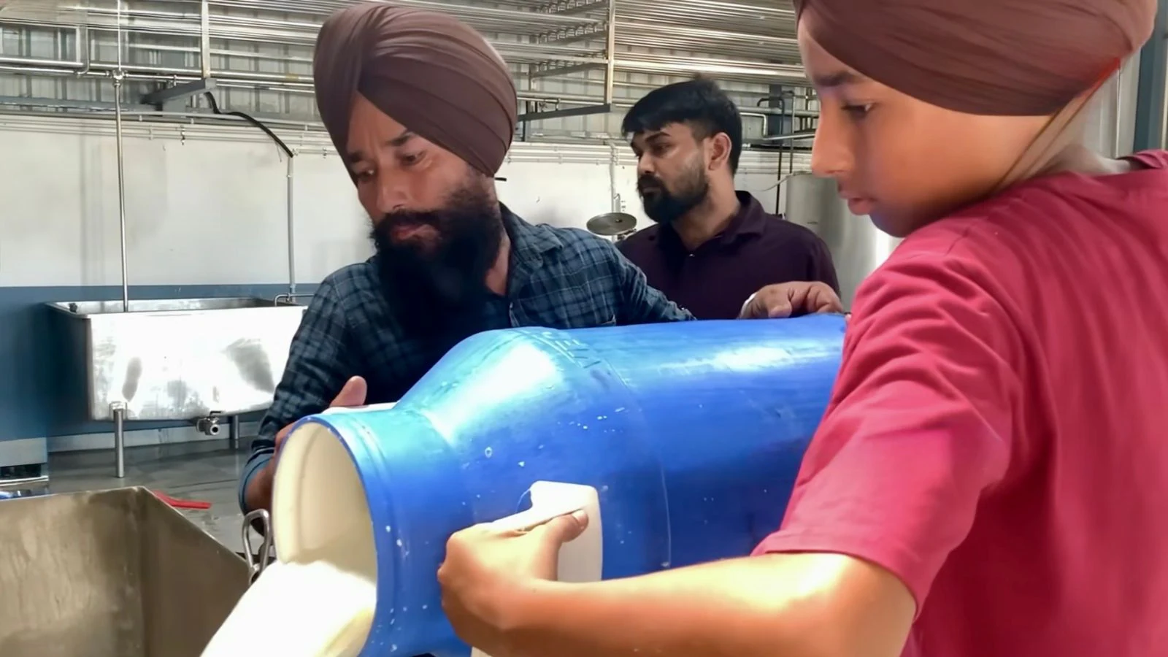
Nine months ago, two marginal farmer brothers at a small village in Punjab embarked on an ambitious journey. Armed with determination, family support and borrowed money, they established an automatic milk processing plant worth Rs 1 crore with the dream of creating a trusted dairy brand — that dream is rapidly turning into a reality. In less than a year, the monthly sales of their dairy products surged from around Rs 4 lakh to more than Rs 27 lakh.
Brothers Jasveer (47) and Sukhdev Singh (50) of Hamidi village in Barnala district have not only created employment for their entire joint family, including their four children, and around a dozen other people, but also inspired many farmers to look beyond conventional agriculture.
“Like thousands of Punjabi families, our children wanted to go abroad for higher studies after completing their schooling. We calculated that sending all four children overseas would require more than Rs 1 crore initially,” says Jasveer. “We explained to them that they would still have to work hard abroad to pay for their education and living expenses. So, we thought, why not invest the same amount here, remain together as a family, work hard and build something of our own.”
Jasveer believes the decision transformed their future.
Besides the sibling duo, all their family members actively participate in the business, including their mother Jaswinder Kaur (70), Jasveer’s wife Karamjit Kaur, Sukhdev’s wife Simaranjit Kaur, sons Balraj Singh, Sukhraj Singh and Gurjot Singh, and daughter Harmanjot Kaur. The younger generation balances studies with responsibilities in different aspects of the enterprise.
The story, however, began long before the processing plant was established.
The family owns just about two acres, in which their father cultivated vegetables, and his elder son would assist him in selling the produce.
Jasveer served the Indian Army for 17 years and retired in 2015. “After returning home, we thought of doing something different and started a small dairy with four buffaloes, as Sukhdev had received training in dairy farming. From four, we increased the number to eight, and gradually expanded to around 25 to 30 buffaloes. Before establishing the processing plant, we were primarily focused on milk production,” Jasveer said.
The turning point came when the brothers attended dairy development seminars in their village and later in Ludhiana. There, they interacted with dairy experts, including Professor Gopika Talwar of Guru Angad Dev Veterinary and Animal Sciences University (GADVASU), who encouraged them to move beyond selling raw milk and focus on value-added dairy products for higher margins.
Jasveer subsequently underwent a week-long training programme and visited several dairy processing facilities, including a Verka plant, to understand modern dairy operations. “The training completely changed our outlook. Convinced about the potential of dairy processing, the family decided to take a bold step.”
They invested nearly Rs 1 crore, including about Rs 90 lakh as the initial project cost, in establishing an automatic milk processing unit. The brothers availed a Rs 40 lakh loan for five years under the Prime Minister’s Employment Generation Programme (PMEGP) and received a subsidy of Rs 10 lakh under the scheme. The remaining investment was arranged through borrowings from relatives, friends and villagers who trusted the family’s vision.
The dairy plant was commissioned in August 2025 and registered under the brand name ‘Milko Fort’. The plant is equipped with modern infrastructure, including a laboratory, Bulk Milk Cooler (BMC), dump tank, homogeniser, holding system, hot room and cold room facilities. Initially, the unit processed barely 200 litres of milk per day, but it has now increased to around 1,500 litres, as demand continues to rise steadily. The plant’s installed capacity is 8,000 litres of milk per day, indicating substantial room for future expansion.
The dairy manufactures a range of traditional products, including curd, cream, paneer, desi ghee, butter, khoya and panjiri.
Every day, around 800 to 900 litres of milk are converted into curd. Significant quantities are also used for producing nearly one quintal of paneer, besides other value-added products.
Paneer is sold for Rs 300-Rs 350 per kilogram, curd for around Rs 60 per kilogram, while desi ghee is for nearly Rs 800 per kilogram. Daily sales range between Rs 90,000 and Rs 1 lakh.
The family pays nearly Rs 75,000 every month as loan instalments, while simultaneously expanding their business.
“In the beginning, we used milk only from our own buffaloes. Later, we started collecting milk from fellow villagers and people from nearby villages on the condition that there must not be adulteration,” Jasveer said.
Milk received at the plant is first tested in the laboratory and then accepted.
The plant is fully registered and operates with all required licences, including FSSAI certification.
“We decided from day one that quality would never be compromised. Customers may come out of curiosity, but they return only when they trust the product,” he says.
Although monthly sales have crossed Rs 27 lakh and the business is operating with a profit margin of over 10 per cent after meeting expenses, the family’s immediate priority remains debt repayment and expansion rather than personal financial gains.
The business has also embraced digital marketing. Orders increasingly arrive through dealers across half a dozen districts and through WhatsApp, while courier services are being used to deliver products outside the district. “During the winter season, several Non-Resident Indians (NRIs) placed orders for traditional products such as panjiri, desi ghee and khoya, helping the family expand its customer base beyond Punjab,” Sukhdev said.
Rapid growth in sales has been accompanied by significant investment in logistics. “We have already purchased four commercial vehicles for milk collection and product distribution,” Sukhdev’s son Gurjot said.

