Farmers’ column: With innovation in irrigation, Haryana farmer sells 10 crores vegetable nursery plants annually
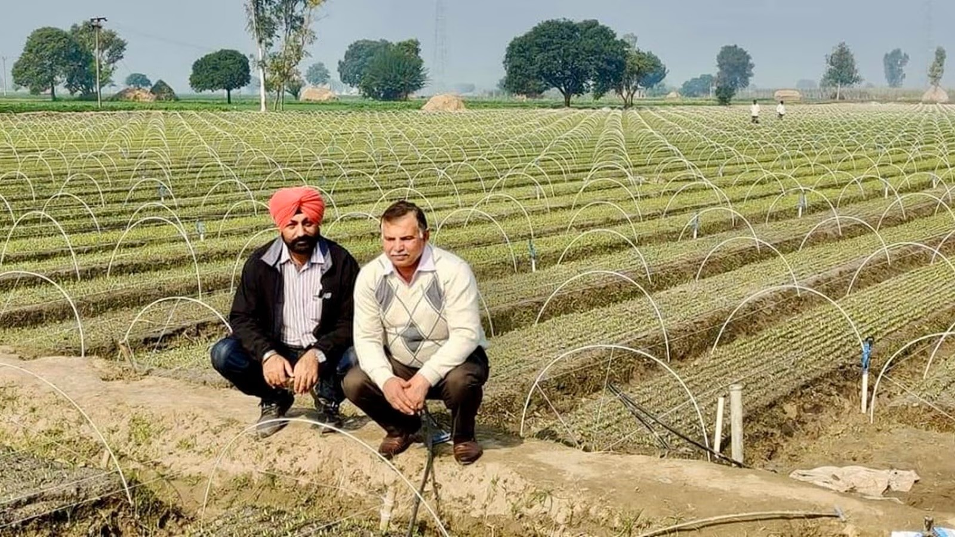
Across Dadlu village in Shahbad Markanda, Kurukshetra, Harbir Singh Toor is a name that now resonates across India’s horticulture industry.
From conventional farming, the 49-year-old Haryana farmer’s journey to selling crores of nursery plants is a story of passion, persistence and innovation.
With little knowledge, Toor started with growing a couple of 1000s of nursery plants over two decades ago. Today, however, he sells around 10 crores (100 million) vegetable nursery plants annually as an expert.
“I am now selling around 10 crores nursery plants annually and have employed 135 persons — 35 permanent and the rest for six to seven months each year,” he said. After meeting input and labour costs, he earns a good profit margin in crores.
His farming career began in 1995 while he was pursuing his post-graduation in Political Science. He started with traditional crops like wheat and paddy but soon felt a lack of innovation or versatility. “I felt the returns were not promising. This led me to explore new avenues.”
He had also experimented with beekeeping and achieved success, but had to quit later due to family constraints.
Steering towards a new experience again, he started cultivating vegetables on a small piece of land, which made him realise the innovation and versatility of the field.
In 2003, he started vegetable nursery cultivation on just two kanals (approximately 1/4 acre); over the next five years Toor expanded his cultivation to 16 acres — a move that was a game-changer.
Initially, he visited a big nursery run by a corporate house in Jalandhar to procure nursery plants, which was a disappointing experience. He was denied entry, did not receive much guidance and ended up with a low-demand chilli variety that fetched poor returns.
It only pushed him to start his nursery where farmers could receive quality seedlings as well as proper guidance.
He now receives seed varieties from big companies for testing. These seeds undergo rigorous evaluation for their adaptability to local conditions. Over time, Toor selects and refines his seeds based on years of testing and feedback.
Toor explains that adapting to the demands of the local mandi (market) has played a key role. “Our focus is on producing seasonal vegetables that are in high demand.” His nursery grows a wide variety of crops like tomatoes, onions, capsicum of different colours, chilli, karela (bitter gourd), tori (ridge gourd), melons of various colours and more.
From November to March, he focuses on onion, normal to late-season tomato varieties, chillies, capsicum and other spring vegetables for the early summer market.
His precise timing ensures the right crops are available at the right time, making his nursery a reliable supplier for local and regional markets.
The Haryana farmer has also introduced a trace of innovation to his irrigation methods. He uses sprinklers, low tunnel farming and all the latest techniques for precise farming.
“When my fields get free from the nursery between February and March, I also sow vegetables and take one crop before sowing paddy in July in around 10 acres. The remaining fields are dedicated to early cauliflower nursery and marigold nursery.”
One of the other groundbreaking aspects of Toor’s business is his growing medium — a mixture of three ingredients which are burnt rice husk, river sand and biogas waste (from his own biogas plant). This medium retains moisture from the air and reduces water usage. “After germination, there is no need for extra watering. Air moisture is sufficient for the plants.”
He prepares 60×3.3 feet beds, lays a 2.5-inch layer of the medium and sows the seeds in the rows. This innovation not only saves water but also enhances quality and sustainability. His method has attracted the attention of agricultural experts globally.
In February 2023, he presented his findings at the World Horticulture Centre in the Netherlands, showcasing his water-saving techniques. “The ratio of the mixture of three ingredients is different for the different crops and also depends on the climate which I learnt gradually.”
Toor’s innovative approach has earned him state and national recognition. He has received numerous accolades, including the Kisan Ratan and Nursery Ratan awards from Haryana and N G Ranga National Award from ICAR (Indian Council of Agriculture Research) in 2017.
Over the years, he has contributed to agricultural research, collaborated with universities and regularly trains students from various agricultural colleges. “Now students from colleges and universities come to me for training. Also under an MOU, I go there to deliver lectures in the horticulture field. They even stay here to learn… cheap and efficient irrigation systems.”
Toor’s nursery supplies vegetable seedlings to markets across various states. His next major goal is to develop and promote cost-effective irrigation systems, making high-quality technology accessible for small farmers, and to expand into fruit and tissue-culture plants.
Toor’s journey from conventional farming to nursery cultivation has involved a chain of experimentation, trial and error, and success.

